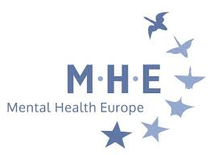

MHE ANNUAL GENERAL ASSEMBLY
Slovenia, 21st April 2018

NOMINATION FORM
MEMBERSHIP AND ACCREDITATION COMMITTEE (MAC)
2018-2021

Rules and Guidelines:

- Membership is open to all members (Full, Supporting, Individual) of MHE who are not candidates for Board membership;
- Candidates should be able to work effectively in English and should be willing to dedicate some time to supporting the work of the MAC, including through regular e-mail work and (at least) one meeting in person per year (costs are reimbursed for MAC members to attend those meetings);
- The MHE Board will appoint the most suitable candidates taking into consideration the gender, geographical balance and the respective experience of the person and knowledge of MHE and its membership;
- A short CV or motivation statement should be attached to this nomination form;
- Nominations must reach the MHE office no later than Friday 23rd February (by email to maria.nyman@mhe-sme.org)

I hereby express my interest to become a member of the MAC:

Name: ………………………………………………………………………………………………

Organisation (except for individual members):

…………………………………………………………………………………………………………………………………..

Full address …………………………………………………………………………………………………………....

……………………………………………………………………………………………………………………………………

Tel : ……………………….…. e-mail : …………………………………

Date : Signature

Do not forget: A CV and short statement shall be attached to this nomination form.

